**General Pre/Post Processing**

**Frequency Band-Pass Filtering**

* First step of processing, included in most EEG transforms such as fourier
* [Matlabs explination](https://www.mathworks.com/help/signal/examples/practical-introduction-to-frequency-domain-analysis.html)

**MATLAB EEG Analysis**

[**Explanation of Algorithms**](http://www.schmid-werren.ch/hanspeter/publications/2012fftnoise.pdf)

**fft(Y)** will give you a complex-valued output, which is the discrete Fourier transform of Y.

* Distinguishes the signals from
* [Explanation of Fast Fourier Transforms](https://www.dataq.com/data-acquisition/general-education-tutorials/fft-fast-fourier-transform-waveform-analysis.html)
* [MATLAB resources](https://www.mathworks.com/help/matlab/ref/fft.html)
* Problems:

**pwelch(Y, ...., 'twosided')** is giving you a Welch's overlapped segment averaging power spectral density estimate where there is some averaging done to reduce the variability of the spectral estimate. Here you are using the 'twosided' option which gives you the power estimates over an entire period from 0 to the Nyquist. That is wholly unnecessary for a real-valued signal.

* Power Spectral Density analysis
* Integration of Density in analysis allows for option to obtain an estimate of the average power over a given frequency interval
* [MATLAB Resources](https://www.mathworks.com/help/signal/ref/pwelch.html)

**psd(Y)** is using an obsolete syntax. In this case your signal is divided into segments and each segment is multiplied by a Hanning window. I think by default here there is no overlap between the segments, which is not the case in pwelch. In pwelch, the segments overlap, but you can control the amount with an input argument.

* Doesn’t scale data
* Power Spectrum analysis of sorts
* ‘Outdated’

**Problems –**

* [Spectral Leakage](https://community.plm.automation.siemens.com/t5/Testing-Knowledge-Base/Windows-and-Spectral-Leakage/ta-p/432760)
* [Scalloping Loss](https://dspguru.com/files/Scalloping%20Loss%20Compensation-Lyons.pdf)
* Artifacts
  + Foreign EEG (i.e. computers, lights, etc.)

/var/folders/54/0pr76vns51159gfs6c83k5_m0000gn/T/com.microsoft.Word/WebArchiveCopyPasteTempFiles/main-qimg-436acd162b7398642073091f2398be7b

* + - Solution – Record ECG and subtract out of data
  + Blinking artifacts

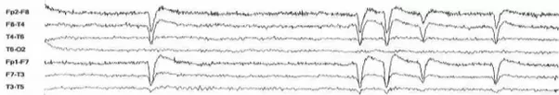

* + Electrode effects (Caused by movement of the electrode during recordings)

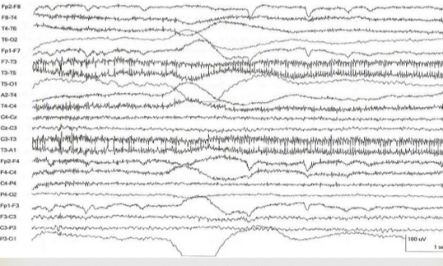

* + - Solution – Avoid recording on people with Oily hair/skin
  + ‘Cocktail party’ problem – How do you know what signal came from where considering each sensor could pic up signals from the others location
    - Solution: Independent component analysis (ICA)

**Tools –**

* [Signal Processing Toolbox](Signal%20Processing%20Toolbox)
* [Extra EEG data handling](https://www.quora.com/How-do-I-process-raw-EEG-data)